### Usability Test:

This is the testing of how much usable the system is. We have different methods to show and evaluate usability testing of site.

|  |  |  |  |  |  |
| --- | --- | --- | --- | --- | --- |
| No | Test Title | Pre-condition | Test Steps | Expected Results | Actual results |
| 7 | Navigation Bar | Open the website | see the top middle position | Menu appears | As expected |

## 

Figure 13: A nav menu bar appears

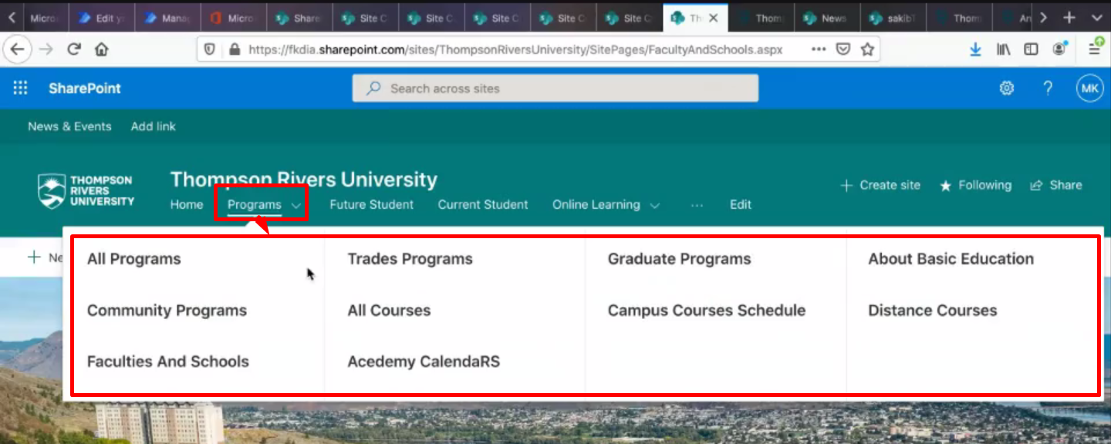

Figure 13.1: Expandable dropdown menu as subcategory

|  |  |  |  |  |  |
| --- | --- | --- | --- | --- | --- |
| No | Test Title | Pre-condition | Test Steps | Expected Results | Actual results |
| 8 | Site content/links | Open the website | see and click on different site contents | usable site contents | As expected |

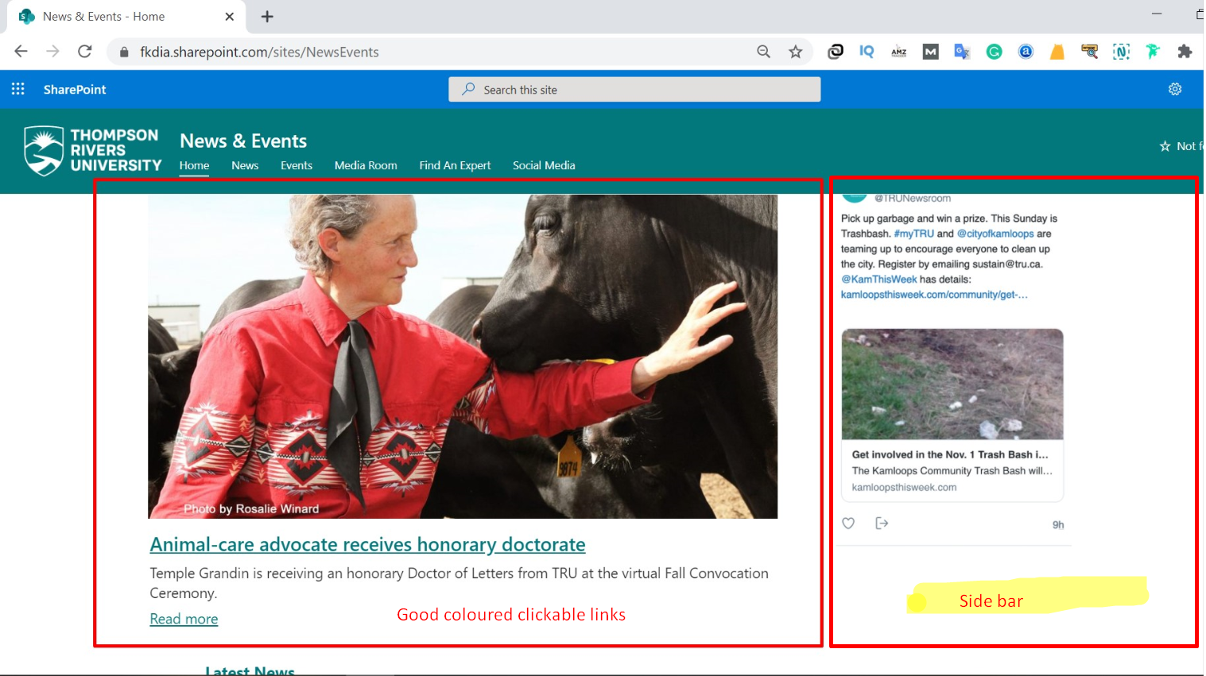

Figure 13.2: Accessible web layout

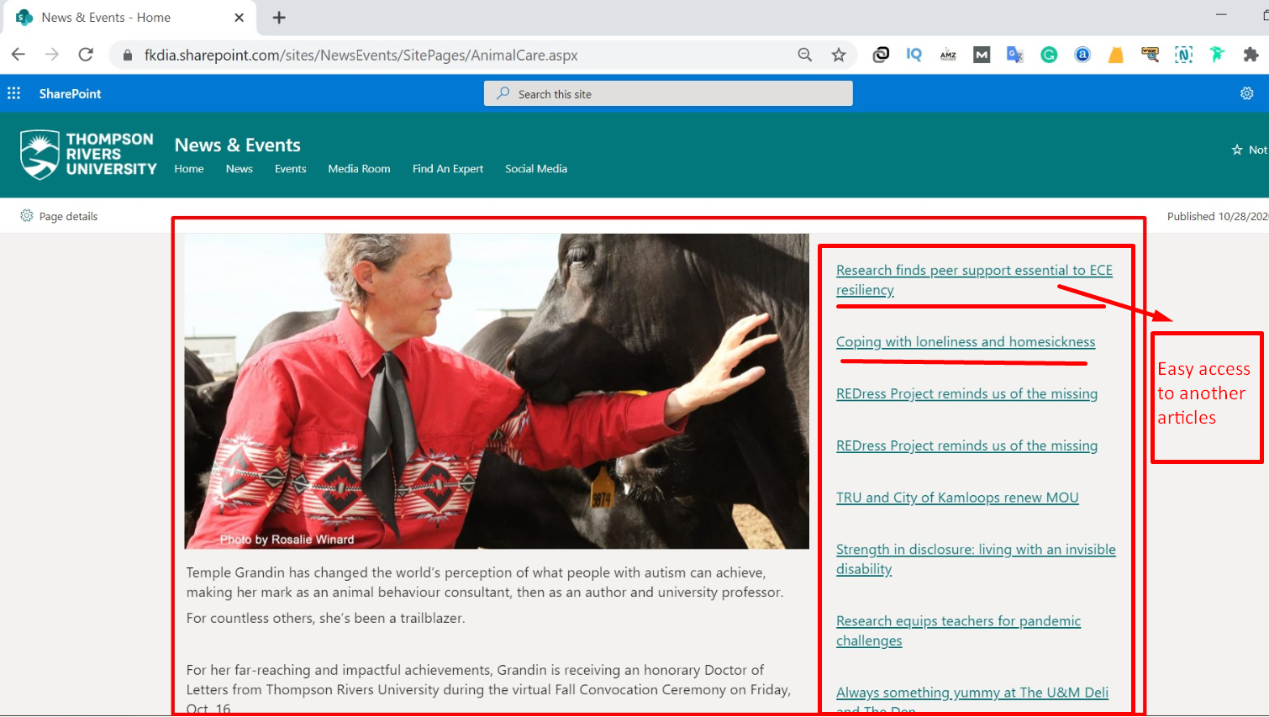

Figure 13.2: Usable link throughout the site